Analysis Anomalous Doppler Effect from quantum theory to classical dynamic simulation

Abstract:

The quantum model is established to analyze the resonance process during the Anomalous Doppler Effect and Normal Doppler Effect, illustrating that the resonance process is related to the wave’s angular momentum. The energy change ratio between the electron’s parallel kinetic energy and cyclotron energy in the magnetic field during the resonance process with electromagnetic wave is given by quantum theory, which agrees remarkably well with numerical calculation.

Introduction:

The Anomalous Doppler Effect (ADE), in which the observed frequency shift behaves contrary to the conventional Doppler Effect under specific conditions, was first theoretically predicted by Soviet physicist Vitaly L. Ginzburg1. This phenomenon occurs when a moving system system’s velocity exceeds the phase velocity of light in the medium, it transfers its kinetic energy to its internal energy while emitting radiation. A notable example, discussed by Frank in his 1958 Nobel lecture2, demonstrates that radiation emission does not result from atomic transitions from a higher (excited) state to a lower state, as is typical, but rather occurs inversely—from a lower state to a higher state—where the energy is supplied by the system’s translational kinetic energy. This intriguing theoretical prediction has attracted significant attention and has motivated extensive research.

In 1967, Artsimovich3 observed discrepancies in tokamak experiments: measurements of electron temperature derived from diamagnetic signals stronger than derived from electrical conductivity measurement. This anomaly, unrecognized at the time, may represent the first experimental observation of ADE. It was not until 1968 that B. B. Kadomtsev4   identified the cause as ADE, wherein electrons’ parallel velocities scatter to circular velocities under resonant ADE conditions. This process amplifies the diamagnetic effect beyond contributions from thermal motion alone. After that, more and more experiment about ADE are observed in experiment such as the electron beam scattering in magnetic field vacuum tube5, and even in tokamak discharge many phenomena related to ADE are reported in previous***.

The physics of the Anomalous Doppler Effect (ADE) was previously briefly explained based on the quantum analysis provided by Frank and Ginzburg**, followed by a quasilinear analysis given by B. In this paper, building on Ginzburg’s quantum analysis and incorporating angular momentum conservation, we present a more detailed analysis of ADE, offering further insights into the relationship between ADE and wave angular momentum. Additionally, we demonstrate numerical simulations based on classical dynamical equations. The energy transfer ratio from kinetic energy to the internal system is derived from both quantum theory and numerical simulations, with results showing strong agreement. This work enhances our understanding of the complex wave-particle interaction phenomenon from a quantum perspective, providing a new perspective for physical interpretation.

Section 1: Quantum analysis of ADE

In this work, we provide an analysis based on the conservation of angular momentum and combined with the quantum analysis given by V.L. Ginzburg[*], I. Tamm[*], Nezlin[*], and I.M. Frank [*].Here we analysis the radiation from the electron moving in medium. when a charged particle moves through a medium at a speed greater than the phase velocity of light in that medium, it induces polarization in the surrounding molecules. As these molecules return to their equilibrium state, they emit electromagnetic radiation. The constructive interference of these emissions produces the characteristic Cherenkov radiation, forming a cone-shaped wavefront as shown in fig.1. The direction of Cherenkov radiation is constrained to the Cherenkov radiation angle ,where c′ is the speed of light in the medium and v is the velocity of the charged particles.

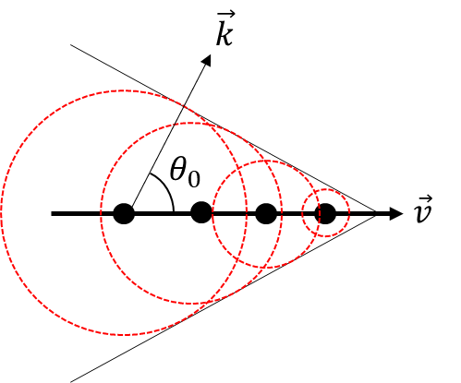

Figure . Schematic diagram of Cherenkov Radiation. The black points stand for the snapshot of the electron at different time, the read dash circle refers to the current radiation surface from the previous electron.

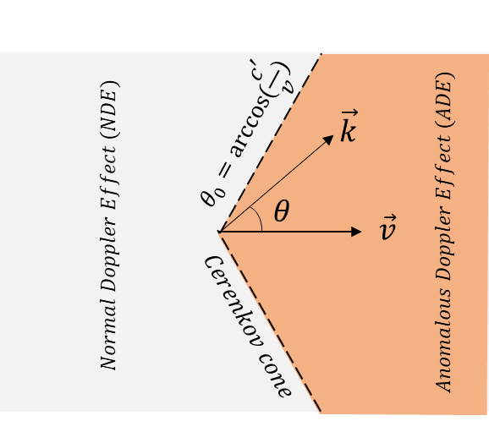

Figure .The region of Anomalous Doppler Effect (ADE) and Normal Doppler Effect (NDE).

In this case, the charged particle is replaced with a system that has internal energy, such as an oscillator or a cyclotron electron in a magnetic field. It emits photons with angular frequency ω and wavevector k in the direction θ. The direction of the emitted photon is not influenced by the interference of secondary waves and can occur in any direction. when the system moves faster than the speed of light (v>c'), the region of ADE and NDE can be divided as shown in Figure 2.

Considering the system emits a photon with angular frequency and wavevector **k,** according to energy conservation and momentum conservation

Here the and represent the kinetic energy and internal energy of the system while subscript of 1 and 2 refer to before and after emitting a photon. p represents the momentum of the system and ℏ represnts reduced Planck's constant. Assumpting that photon’s energhy is far less than the initial kinetic energy , the losses of kinetic energy after emitting a photon can be expressed as , where v is the velocity of the system before emitting a photon and **.** Thus, the change of internal energy can be expressed as

Here, . While the system velocity is greater than the speed of light in the medium . According to the sign of , we can divide radiation into three regions, as shown in Figure 2.

* For , . The system produces photons by consuming its own internal and kinetic energy, this region refers to the Normal Doppler Effect (NDE).
* For , , the loss of kinetic energy by the system is completely converted into photon energy; this line refers to the Cerenkov Effect.
* For , , this region is referred to the Anomalous Doppler Effect (ADE), where the system gains internal energy after emitting photons. It means the loss of kinetic energy is converted to photons and the system’s internal energy.

When the system velocity exceeds the speed of light (v < c’), all three effects are possible While the system velocity is less than the speed of light (v > c’), only Normal Doppler Effect exists. Here, we will first provide a detailed analysis of the relationship between the system's internal energy change after emitting a photon and the characteristics of the photon. A heuristic discussion on the fundamental physics of the wave-particle interaction process will be given.

Let’s consider the process in which an electron cyclotron system under a uniform magnetic field emits a photon, as shown in fig.3. The moving electron has the velocity vz along the background magnetic field and the cyclotron velocity. The kinetic energy along z is , where refers to the Lorentz factor. The internal energy represents as . Assume the angular moment of the system before and after emitting a photon is L1 ,and L2, respectively. The angular moment of photon is n. According to the angular momentum conservation, we have

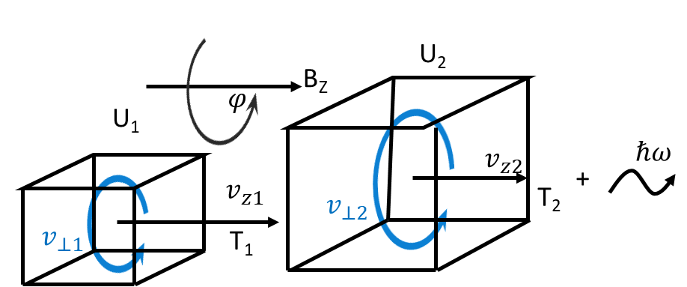

Figure . Schematic diagram of electron cyclotron system before and after emitting a photon. Here U2>U1, T2<T1.

Since the magnetic field is aligned along z direction, the angular momentum of electron cyclotron along z is represents as Lz. According to the quantum theory, the electron wave in the static magnetic field can be expressed as:

With the term represents as normalized coefficient, A is the vector potential and s is the position. The intrinsic equation of angular momentum in the z direction is

As a result, the eigenvalue of can be expressed as

With ,and , the equation * is presented as

Here is the electron rest mass, is the Lorentz factor and is the electron cyclotron frequency in rest frame (). The angular momentum conservation in z direction is The variation in the angular momentum of the electron along z is presented as

With m is the number of photon’s angular momentum in z direction.The internal energy change is given by , with the eq.*, will be transformed as :

According to the eq.* and eq.*, the change in electron energy could be presented as

Here, represents the loss of kinetic energy , represents the energy of the photon, and represents the change in the electron cyclotron energy (internal energy change). The change ratio of internal energy and kinetic energy can be expressed as

This results is a critical criterion to compare with the classical dynamic simulation in the section 3 .

After simpifying the eq.*, we finally have the classical wave-particle resonant condition

Based on the analysis above, the m actually represents the quantum number of angular momentum of the photon. There are three scenarios about the sign of m.

* For , , the cyclotron electron internal energy decreases after emitting a photon, and the emitted photon will have right-hand circular polarization with angular momentum to maintain angular momentum conservation. This process is called the Normal Doppler Effect .
* For , , the Cherenkov Effect occurs, where the emitted photon does not cause any change in the internal energy of the cyclotron electron.
* For , , the Anomalous Doppler Effect (ADE) occurs,resulting in an increase in the internal energy of the cyclotron electron and the emission of left-hand circular polarization with angular momentum .

The aforementioned analysis is based on spontaneous emission. However, similar to laser emission, this conservation model is also applicable to stimulated emission, wherein the emitted photon is generated with the same frequency, direction, and phase as the incident photon. External electromagnetic waves can serve as resonant fields to trigger cyclotron electrons in a magnetic field to emit or absorb waves, providing a framework for analyzing the Anomalous Doppler Effect. For a external electromagnetic wave as plane wave, the wave angular moment number can be devided into . While for , it indicates that the resonant wave possesses a helicon structure. In this study, we consider only the primary resonant conditions : the ADE resonantce condition, **,**

and the NDE resonance condition, **.**

Section 2 : Classical dynamic simulation of ADE

We have presented the ADE process based on the quantum theory and demonstrated that the angular momentum of the stimulated EMW determines the resonant condition. Specifically, only angular momentum with m < 0 corresponds to the ADE process, while m >0 corresponds to the NDE process. The enery transfer ratio between interanl energy and kinetic energy during resonance can be expressed as , and the ratio between the energy done by photon and the change of kinetic energy during resoance can be expressed as .

To analyze the ADE process from the perspective of classical dynamics and to provide a direct comparison between quantum and classical dynamic results, the following scenario is established: The uniform magnetic field is set along the z-direction. The electrostatic field , which on the opposite direction to as shown in Fig. *, is used to accelerate the electron. A plane, linearly polarized slow electromagnetic wave is established as induced wave, characterized by frequency 𝜔 and wavevector **k**. This type of slow wave commonly exists in plasmas or corrugated waveguides.. ***

The six-dimensional phase space of an electron, described by its position **r** and momentum **p,** under this scenario is presented in eq.*. The vectors **E** and **B** represent the total field, including both static and electromagnetic components. Here, c denotes the speed of light in vacuum, e represents to the electron’s charge and m0 is the electron’s mass in rest frame.

To simulate the evolution of r and p , the eq.* is discreted as the form of eq.* based on the Volume-Preserving Algorithm***. Here the k is the iteration step and the operator Cay(A) denotes the Cayley transform of matrix A [*].

The dimensionless parameters are momentum , magnetic field total electric field ,time step , and position respectively, where the is the electron cyclotron period and is Lorentz factor. The dimensionless magnetic matrix B* is writen as eq.(*)

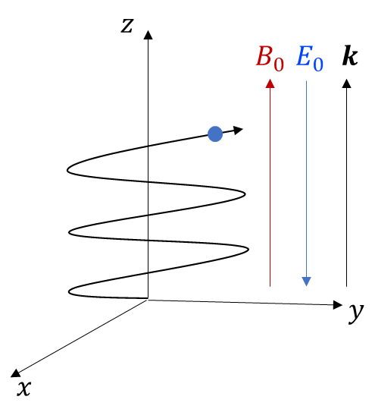

Figure .The uniform static magnetic field is set along the z axis, the electrostatic field E0 is oriented opposite to the B0 field, and the wavevector k is aligned parallel to the B0 field.

To illustrate the system evolution and achieve highly efficient calculation, the parameters are set as following: background magnetic field , wave angular frequency where , wavevector , the electric field component of the electromagnetic wave , and the electrostatic field is . The time step is always chosen to satisfy 50()) to ensure the accuracy of the simulation.

The evolution of the electron’s motion is shown in Fig. 5. As the electron accelerates in the electrostatic field (Fig. 5(b)), the resonant frequencies increase simultaneously (Fig. 5(a)). The change of parallel velocity caused by electromagnetic wave can be quantified as as shown in Fig.5(c), where vz represents the parallel velocity under the given scenario, while vzE0​ denotes the parallel velocity resulting solely from the electrostatic field, which can be calculated using a theoretical equation. The cyclotron velocity is shown in Fig.5 (d). The work done by electromagnetic wave is shown in Fig.5 (e), which can be calculated by integrating the power with time as ,and . Since all discrete date points are available from the simulation , it is no difficult to integrate all the discreate date over time. Figure.5(f) shows the cyclotron energy evolution with time, where .

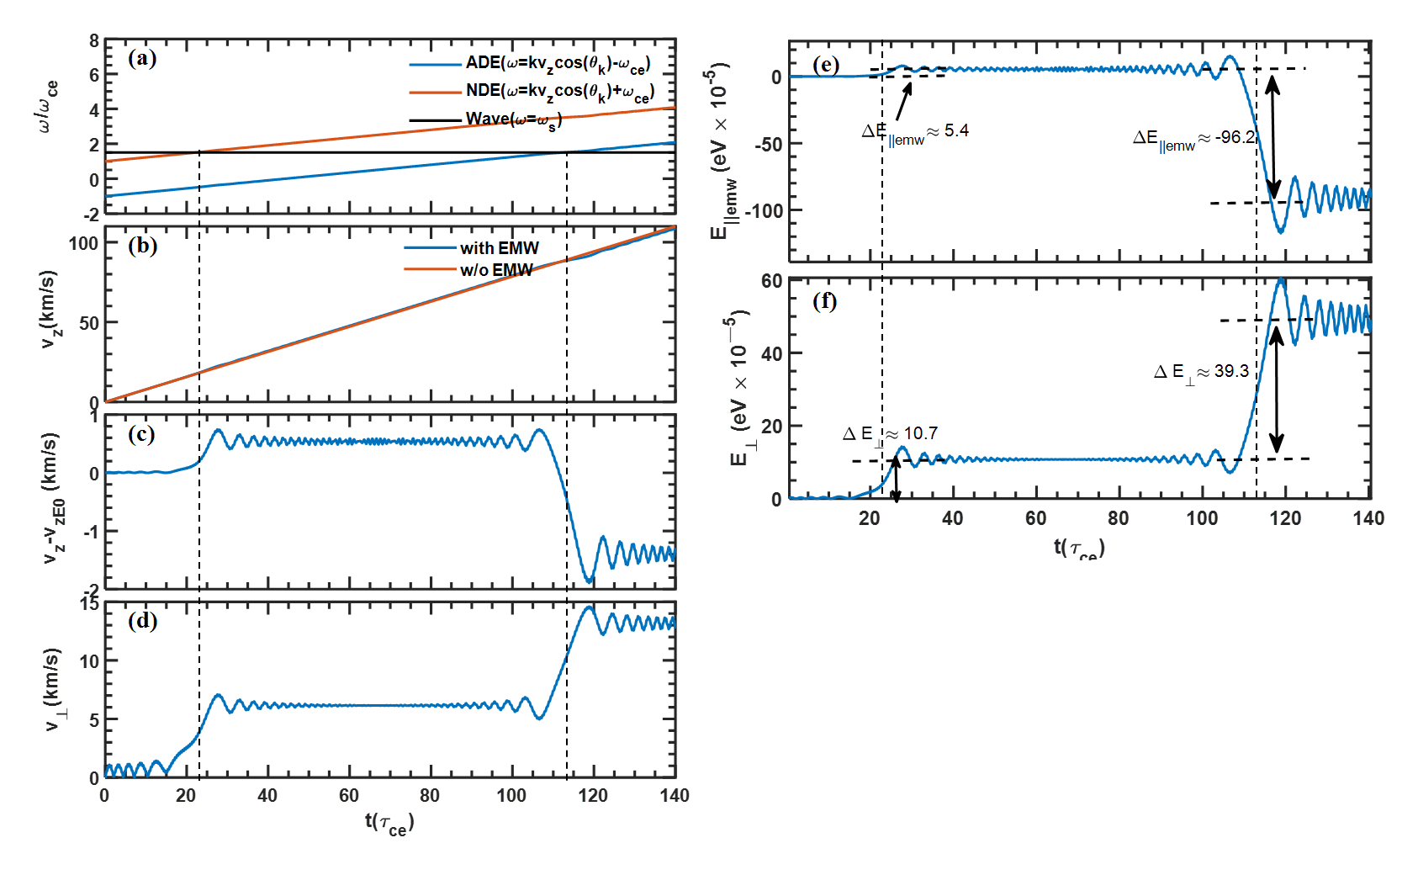

Figure .Kinetic evolution of electrons in a magnetic field with electromagnetic wave during acceleration. (a) Wave frequencies of Anomalous Doppler Effect (ADE), Normal Doppler Effect (NDE), and source wave frequency. (b) The parallel velocity vz in the case with and without the electromagnetic wave. (c) The change of parallel velocity caused by the electromagnetic wave. (d) The cyclotron velocity .(e) The parallel kinetic energy by electromagnetic wave. (f)The evolution of cyclotron energy.

At around 23 , the Normal Doppler Frequency matches that of the induced wave (Fig.5(a)), leading to a rapid increase in the cyclotron velocity (Fig.5 (b)). Simultaneously, the change in parallel velocity induced by the electromagnetic wave also increases. This phenomenon can be interpreted as the electron cyclotron system absorbing a photon during the Normal Doppler Effect, resulting in an increase in both parallel kinetic energy and cyclotron energy. The change in parallel kinetic energy caused by the electromagnetic wave is shown in Fig. 5(e), where . The increase in cyclotron energy is shown in Fig.5 (e), where . The enery transfer ratio between interanl energy and kinetic energy during resonance is given by . According to quantum theory, the energy ratio is given by

Here m =1 for NDE and k = along z axis ,the resonant velocity vz 19 103m/s and . Finally, , which is in close agreement with the simulation results.

The Anomalous Doppler Effect begins to emerge when the time reaches 113 , where as shown in Fig.5 (a). At this point, the parallel velocity begins to scatter into the cyclotron direction, evident from the decrease in and the increase in as seen in Fig.5 (c) and Fig.5 (d). During the resonant period, the changes in parallel and cyclotron energies caused by electromagnetic wave are calculated as and . The enery transfer ratio is . According to quantum theory, the change ratio of =,where , and k = 105 /m, vz = 90 km/s. The quantum theory results are in good agreement with the numerical calculations.



Reference

1. Ginzburg, V. L., and I. M. Frank. "Radiation from a uniformly moving electron passing from one medium to another." *Journ. of Experimental and Theoretical Physics (JETP) V* 16 (1946): 15-26.
2. Frank, I. M. "Optics of Light Sources Moving in Refractive Media: Vavilov-Cherenkov radiation, though interesting, is but an experimental instance of a more general problem." *Science* 131.3402 (1960): 702-712.
3. Artsimovich, L. A., et al. "Thermal insulation of plasma in the “Tokamaks”." *Soviet Atomic Energy* 22.4 (1967): 325-331.
4. KADOMTSEV B, POGUTSE O. Electric conductivity of a plasma in a strong magnetic field [J]. Sov. Phys. JETP, 1968, 26: 1146.
5. Shustin E, POPOVICH P and Kharchenko I 1971 Transformation of Electron Beam Distribution Function Following Cyclotron Interaction with a Plasma *SOVIET PHYSICS JETP* **32**